**EXPERIMENT NO. 2**

**Aim:** To Study set, range, List, Tuple, Dictionary and string data types in python.

**Problem Statements:**

1. Implement a program to store a matrix using nested list and fetch index element of matrix

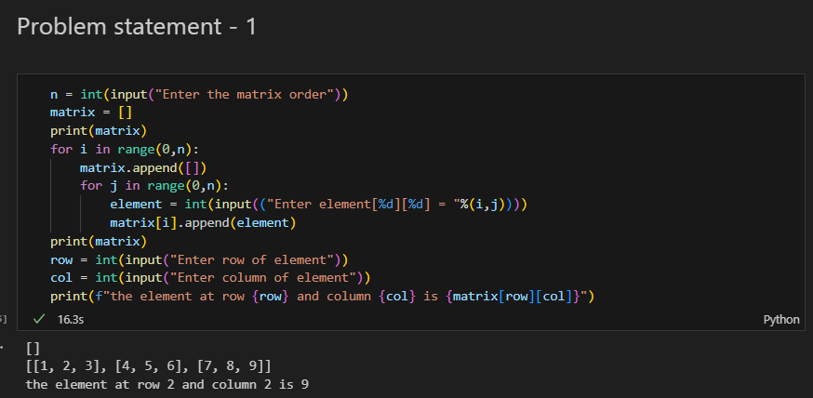

1. Create a list of 10 random players in football team. perform following operations on list and discuss on each output 1. Display list, Sorts the list, use remove to Remove the first item with the specified value

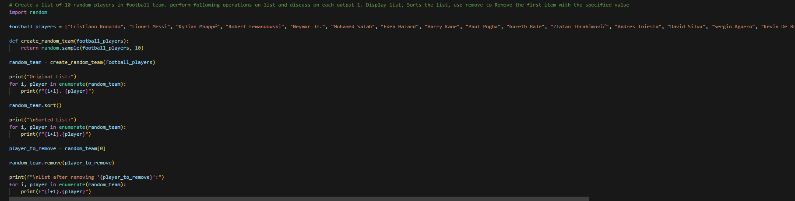

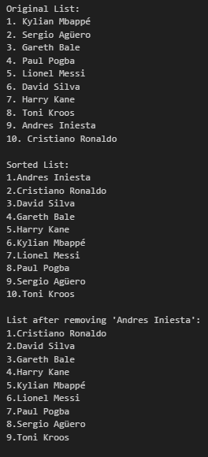

1. Write a program to randomly select 10 integer elements from range 100 to 200 and find the minimum and maximum among all.

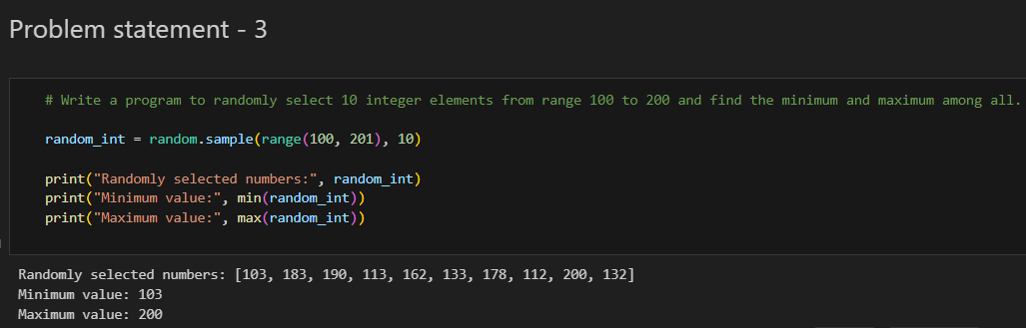

1. Create a dictionary of 5 countries with their currency details and display them

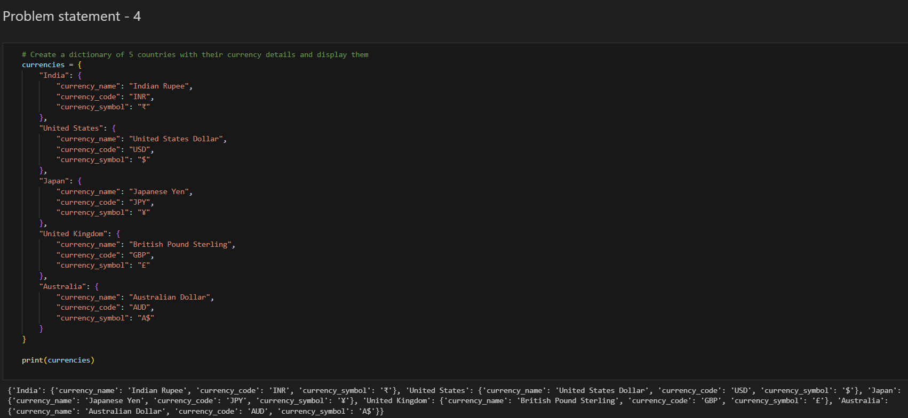

**Theory:**

**Python Number:**

Number data types store numeric values. Number objects are created when you assign a value to them.

Python supports four different numerical types −

* int (signed integers)
* long (long integers, they can also be represented in octal and hexadecimal)
* float (floating point real values)
* complex (complex numbers)

**1. Set**

A Set in Python programming is an unordered collection data type that is iterable, mutable and has no duplicate elements.

Set are represented by { } (values enclosed in curly braces)

The major advantage of using a set, as opposed to a list, is that it has a highly optimized method for checking whether a specific element is contained in the set. This is based on a data structure known as a hash table. Since sets are unordered, we cannot access items using indexes as we do in lists.

**Example of Python Sets**

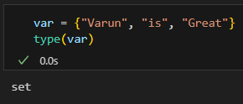

Python sets can store **heterogeneous elements** in it, i.e., a set can store a mixture of string, integer, boolean, etc datatypes.

**Frozen set**

While elements of a set can be modified at any time, elements of the frozen set remain the same after creation.

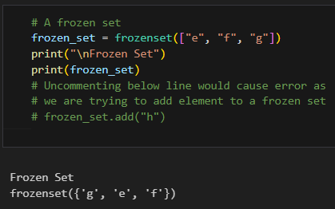

**Methods for Sets**

**Adding elements to Python Sets**

Insertion in the set is done through the set.add() function, where an appropriate record value is created to store in the hash table. Set1.add(2);

**Union operation on Python Sets**

Two sets can be merged using union() function or | operator. Both Hash Table values are accessed and traversed with merge operation perform on them to combine the elements, at the same time duplicates are removed.

Set1.union(set2) or set1|set2

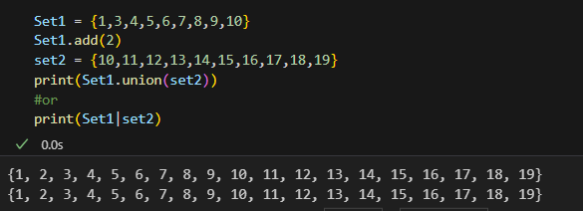

**Intersection operation on Python Sets**

This can be done through intersection() or & operator. Common Elements are selected. They are similar to iteration over the Hash lists and combining the same values on both the Table.

Set1.intersection(set2) or set1&set2

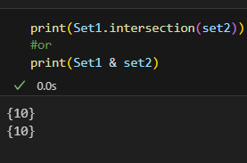

**Finding Differences of Sets in Python**

To find differences between sets. Similar to finding differences in the linked list.

set1.difference(set2) or set1-set2

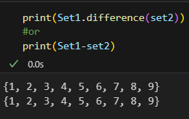

**Set Clear()** method empties the whole set inplace.

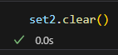

**Append Multiple Elements in Set in Python**

**update() Method**

In this method, we will use Python‘s in-built set update() function to get all the elements in the list aligned with the existing set.

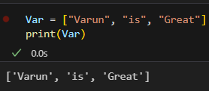

**Using | Operator (Pipe Operator)**

The pipe operator internally calls the union() function, which can be used to perform the task of updating the Python set with new elements.

**here are two major pitfalls in Python sets:**

* The set doesn’t maintain elements in any particular order.
* Only instances of immutable types can be added to a Python set.

**Range**

The Python range() function is used to generate a sequence of numbers. Depending on how many arguments the user is passing to the function, the user can decide where that series of numbers will begin and end as well as how big the difference will be between one number and the next.range() takes mainly three arguments.

start: integer starting from which the sequence of integers is to be returned

stop: integer before which the sequence of integers is to be returned.   
The range of integers ends at a stop – 1.

step: integer value which determines the increment between each integer in the sequence.

**2. Python List:**

A list is a collection of things, enclosed in [ ] and separated by commas.

The list is a sequence data type which is used to store the collection of data. Tuples and String are other types of sequence data types.

Example:

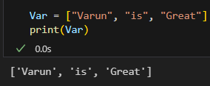

Lists are the simplest containers that are an integral part of the Python language. Lists need not be homogeneous always which makes it the most powerful tool in Python. A single list may contain DataTypes like Integers, Strings, as well as Objects. Lists are mutable, and hence, they can be altered even after their creation.

Creating a List in Python

Lists in Python can be created by just placing the sequence inside the square brackets[]. Unlike Sets, a list doesn’t need a built-in function for its creation of a list.

**Note:** Unlike Sets, the list may contain mutable elements.

Example:

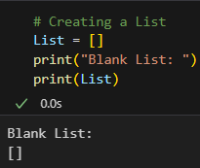

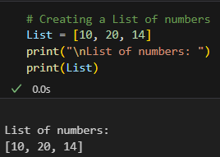

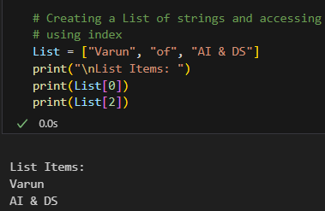

**Creating a list with multiple distinct or duplicate elements**

A list may contain duplicate values with their distinct positions and hence, multiple distinct or duplicate values can be passed as a sequence at the time of list creation.

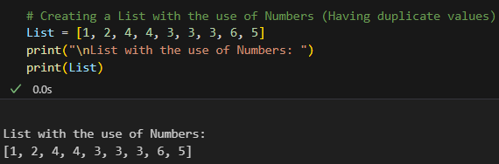

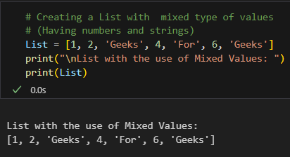

**Accessing elements from the List**

In order to access the list items refer to the index number. Use the index operator [ ] to access an item in a list. The index must be an integer. Nested lists are accessed using nested indexing.

**Example:**

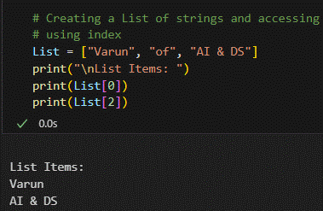

**Example 2: Accessing elements from a multi-dimensional list**

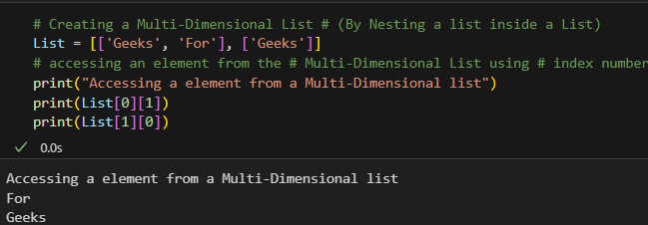

**Negative indexing**

In Python, negative sequence indexes represent positions from the end of the array. Instead of having to compute the offset as in List[len(List)-3], it is enough to just write List[-3]. Negative indexing means beginning from the end, -1 refers to the last item, -2 refers to the second-last item, etc.

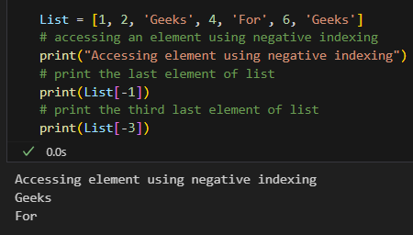

Getting the size of Python list

Python len() is used to get the length of the list.

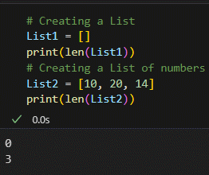

**Taking Input of a Python List**

We can take the input of a list of elements as string, integer, float, etc. But the default one is a string.

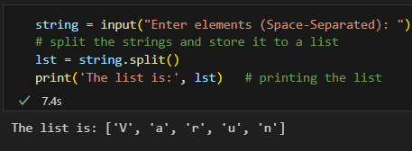

**Adding Elements to a Python List**

**Method 1: Using append() method**

Elements can be added to the List by using the built-in append() function. Only one element at a time can be added to the list by using the append() method, for the addition of multiple elements with the append() method, loops are used. Tuples can also be added to the list with the use of the append method because tuples are immutable. Unlike Sets, Lists can also be added to the existing list with the use of the append() method.

**# Python program to demonstrate # Addition of elements in a List**

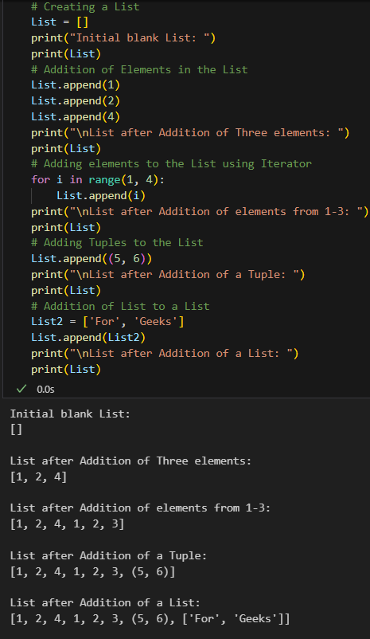

**Method 2: Using insert() method**

append() method only works for the addition of elements at the end of the List, for the addition of elements at the desired position, insert() method is used. Unlike append() which takes only one argument, the insert() method requires two arguments(position, value).

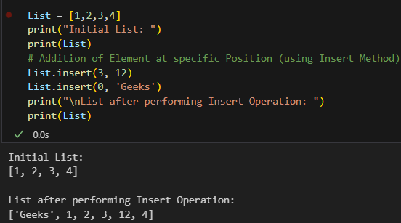

**Method 3: Using extend() method**

Other than append() and insert() methods, there’s one more method for the Addition of elements, extend(), this method is used to add multiple elements at the same time at the end of the list.

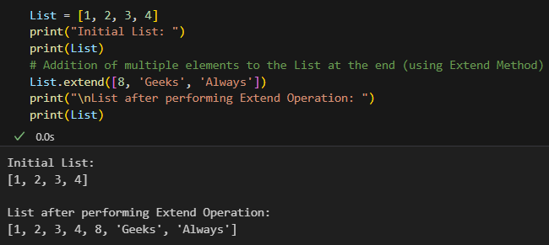**Reversing a List**

**Method 1: A list can be reversed by using the reverse() method in Python.**

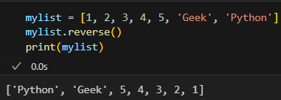

**Method 2: Using the reversed() function:**

The reversed() function returns a reverse iterator, which can be converted to a list using the list() function.

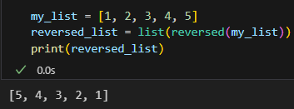

**Removing Elements from the List**

**Method 1: Using remove() method**

Elements can be removed from the List by using the built-in remove() function but an Error arises if the element doesn’t exist in the list. Remove() method only removes one element at a time, to remove a range of elements, the iterator is used. The remove() method removes the specified item.

**Note:** Remove method in List will only remove the first occurrence of the searched element.

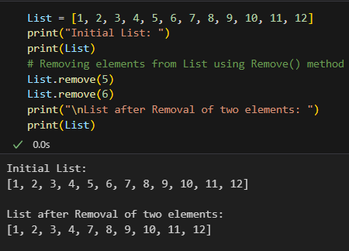

**Method 2: Using pop() method**

pop() function can also be used to remove and return an element from the list, but by default it removes only the last element of the list, to remove an element from a specific position of the List, the index of the element is passed as an argument to the pop() method.

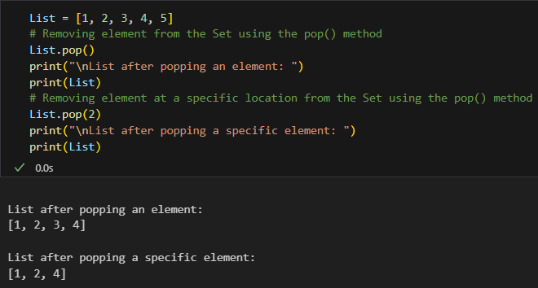

**Slicing of a List**

We can get substrings and sublists using a slice. In Python List, there are multiple ways to print the whole list with all the elements, but to print a specific range of elements from the list, we use the Slice operation.

Slice operation is performed on Lists with the use of a colon(:).

To print elements from beginning to a range use:

[: Index]

To print elements from end-use:

[:-Index]

To print elements from a specific Index till the end use

[Index:]

To print the whole list in reverse order, use

[::-1]

Note – To print elements of List from rear-end, use Negative Indexes.

**List Comprehension**

**Python List comprehensions are used for creating new lists from other iterables like tuples, strings, arrays, lists, etc. A list comprehension consists of brackets containing the expression, which is executed for each element along with the for loop to iterate over each element.**

**Syntax:**

newList = [ expression(element) for element in oldList if condition ]

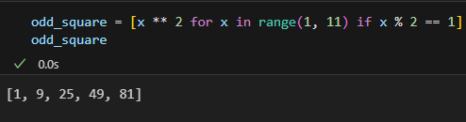

**3. Python Tuple:**

Tuple is a collection of Python objects much like a list. The sequence of values stored in a tuple can be of any type, and they are indexed by integers.

Values of a tuple are syntactically separated by ‘commas’. Although it is not necessary, it is more common to define a tuple by closing the sequence of values in parentheses. This helps in understanding the Python tuples more easily.

Creating a Tuple

In Python, tuples are created by placing a sequence of values separated by ‘comma’ with or without the use of parentheses for grouping the data sequence.

Note: Creation of Python tuple without the use of parentheses is known as Tuple Packing.

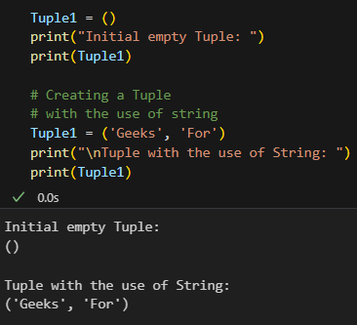

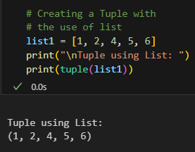

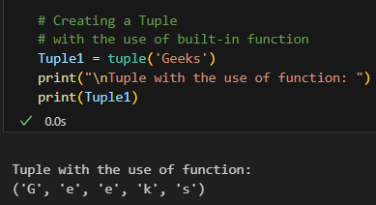

**Creating a Tuple with Mixed Datatypes.**

Tuples can contain any number of elements and of any datatype (like strings, integers, list, etc.). Tuples can also be created with a single element, but it is a bit tricky. Having one element in the parentheses is not sufficient, there must be a trailing ‘comma’ to make it a tuple.

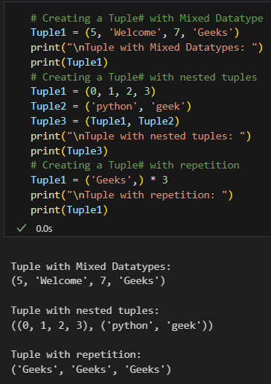

**Accessing of Tuples**

Tuples are immutable, and usually, they contain a sequence of heterogeneous elements that are accessed via unpacking or indexing (or even by attribute in the case of named tuples). Lists are mutable, and their elements are usually homogeneous and are accessed by iterating over the list.

Note: In unpacking of tuple number of variables on the left-hand side should be equal to a number of values in given tuple a.

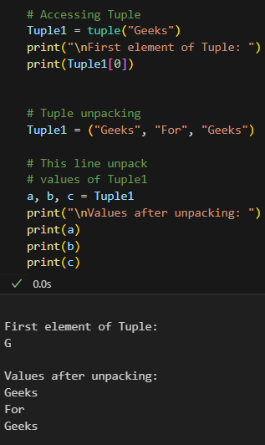

**Concatenation of Tuples**

Concatenation of tuple is the process of joining two or more Tuples. Concatenation is done by the use of ‘+’ operator. Concatenation of tuples is done always from the end of the original tuple. Other arithmetic operations do not apply on Tuples.

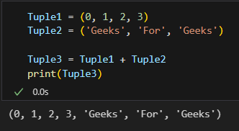

**Deleting a Tuple**

Tuples are immutable and hence they do not allow deletion of a part of it. The entire tuple gets deleted by the use of del() method.

Note- Printing of Tuple after deletion results in an Error.

Tuple1 **=** (0, 1, 2, 3, 4)

**del** Tuple1

print(Tuple1)

#### **Built-In Methods**

|  |  |
| --- | --- |
| **Built-in-Method** | **Description** |
| [**index( )**](https://www.geeksforgeeks.org/python-list-index/) | Find in the tuple and returns the index of the given value where it’s available |
| [**count( )**](https://www.geeksforgeeks.org/python-list-count-method/) | Returns the frequency of occurrence of a specified value |

### 

### **Tuples VS Lists:**

|  |  |
| --- | --- |
| **Similarities** | **Differences** |
| Functions that can be used for both lists and tuples:  len(), max(), min(), sum(), any(), all(), sorted() | Methods that cannot be used for tuples:  append(), insert(), remove(), pop(), clear(), sort(), reverse() |
| Methods that can be used for both lists and tuples:  count(), Index() | we generally use ‘tuples’ for heterogeneous (different) data types and ‘lists’ for homogeneous (similar) data types. |
| Tuples can be stored in lists. | Iterating through a ‘tuple’ is faster than in a ‘list’. |
| Lists can be stored in tuples. | ‘Lists’ are mutable whereas ‘tuples’ are immutable. |
| Both ‘tuples’ and ‘lists’ can be nested. | Tuples that contain immutable elements can be used as a key for a dictionary. |

**4. Python Dictionary:**

Dictionary in Python is a collection of keys values, used to store data values like a map, which, unlike other data types which hold only a single value as an element.

**Example of Dictionary in Python**

Dictionary holds key:value pair. Key-Value is provided in the dictionary to make it more optimized.

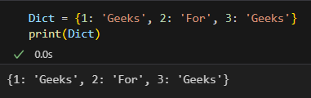

**Creating a Dictionary**

In Python, a dictionary can be created by placing a sequence of elements within curly {} braces, separated by ‘comma’. Dictionary holds pairs of values, one being the Key and the other corresponding pair element being its Key:value. Values in a dictionary can be of any data type and can be duplicated, whereas keys can’t be repeated and must be immutable.

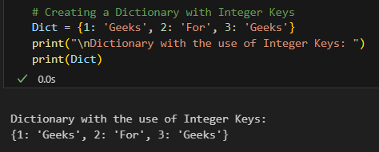

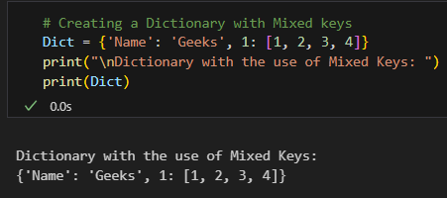

Dictionary can also be created by the built-in function dict(). An empty dictionary can be created by just placing to curly braces{}.

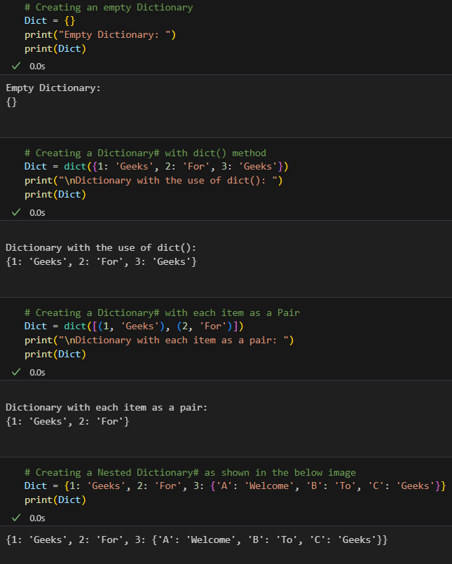**Adding elements to a Dictionary**

Addition of elements can be done in multiple ways. One value at a time can be added to a Dictionary by defining value along with the key e.g. Dict[Key] = ‘Value’. Updating an existing value in a Dictionary can be done by using the built-in update() method. Nested key values can also be added to an existing Dictionary.

Note- While adding a value, if the key-value already exists, the value gets updated otherwise a new Key with the value is added to the Dictionary.

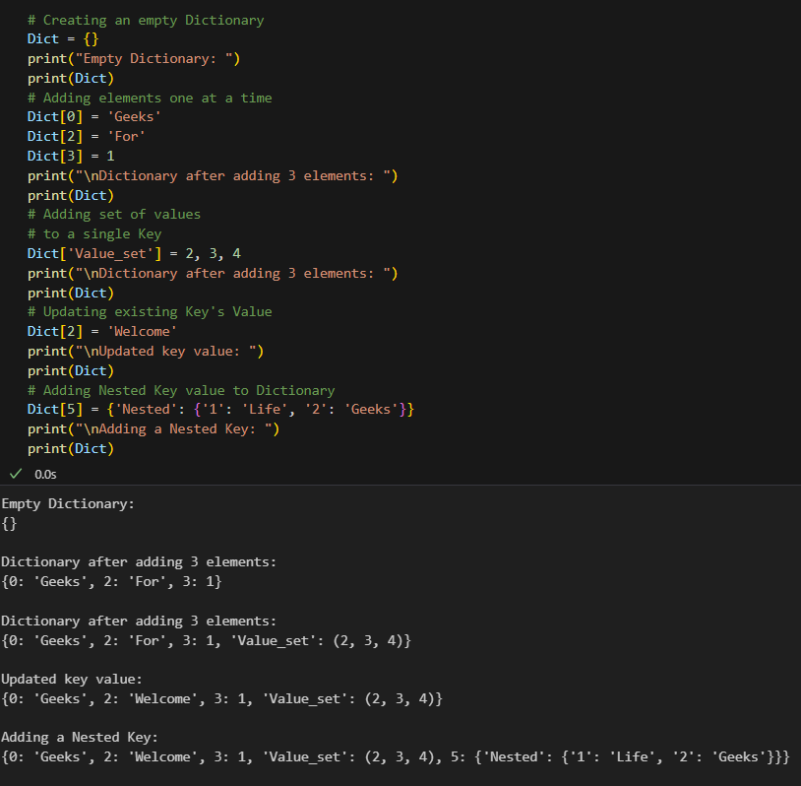Accessing elements of a Dictionary

In order to access the items of a dictionary refer to its key name. Key can be used inside square brackets.

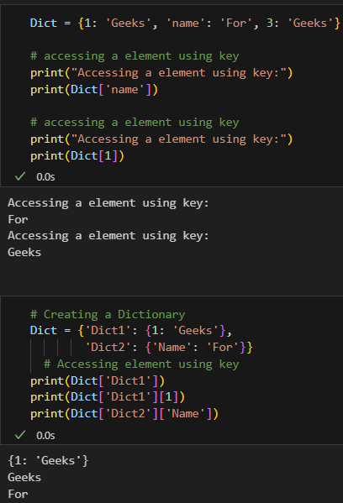

**Deleting Elements using del Keyword**

The items of the dictionary can be deleted by using the del keyword as given below.

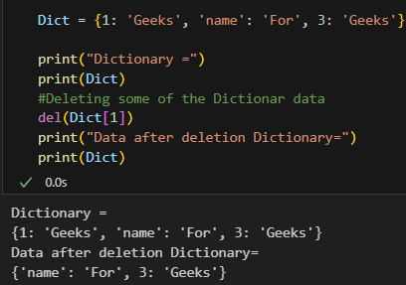

**Lab Outcome:** Thus, studied set, range, List, Tuple, Dictionary and string data types in python.

**Conclusion:** From this experiment I learnt set, tuple, list, dictionary, string and many more data types in python.